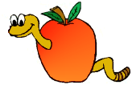
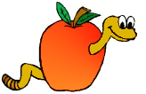
Wormy Word Search
Name: __________________________

List your words and their meanings below. Then use these words to build your own word search game.

Words | Definitions

